Data integration by sample (with doublets removed)

Proportion of doublets and singlets in integrated data

Clustering with doublet removal

Clustering without doublet removal

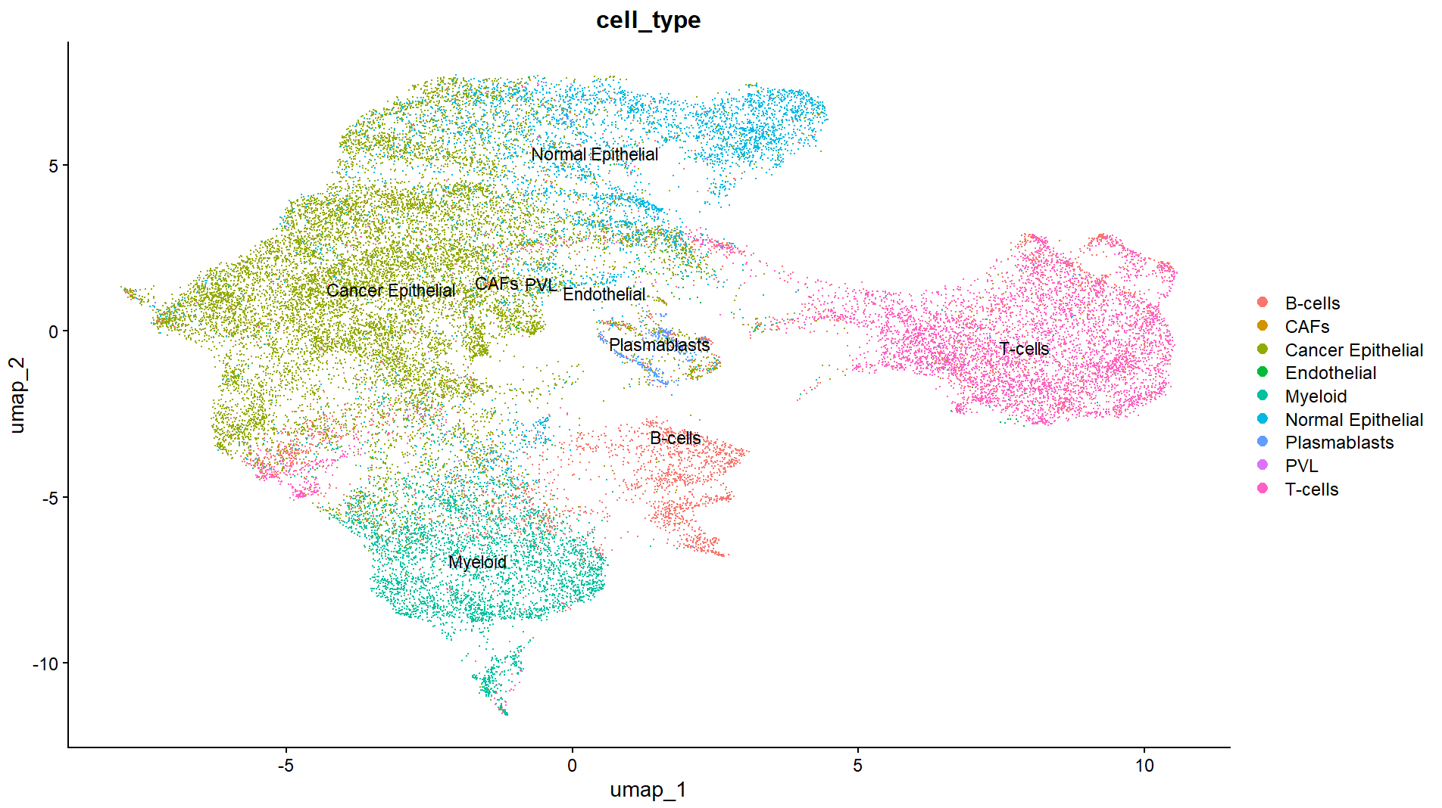

Cell type annotated clusters using a reference dataset

Cell type annotated clusters between conditions